**Q. Given the number of hours and minutes browsed, write a program to calculate bill for Internet Browsing in a browsing center. The conditions are given below.**

**(a) 1 Hour Rs.50**

**(b) 1-minute Re. 1**

**(c) Rs. 200 for five hours**

**Boundary condition: User can only browse for a maximum of 7 hours**

**Check boundary conditions**

PAC

|  |  |  |  |
| --- | --- | --- | --- |
| **Data** | **Processing** | **Output** | **Solution Alternatives** |
| Number of hours  Number of minutes | If (number of hours >= 5 and number of hours < 7),  Bill = 200 + ((number of hours – 5) *50) + (number of minutes * 1)  Else,  Bill = (number of hours*50) + (number of minutes * 1) | Print Bill |  |

Algorithm

* Start
* Use variable **Number_of_hours**, **Number_of_minutes**, **Bill**
* Read **Number_of_hours**, **Number_of_minutes**
* if **Number_of_minutes** >= 60

**Number_of_hours** = **Number_of_hours** + **Number_of_minutes** // 60

**Number_of_minutes** = **Number_of_minutes** % 60

* if **Number_of_hours** >= 7

Print Maximum hours of browsing is 7

else

if **Number_of_hours** >=5

**Bill** = 200 + ((**Number_of_hours** – 5) * 50) + (**Number_of_minutes** * 1)

else

**Bill** = (**Number_of_hours** * 50) + (**Number_of_minutes** * 1)

Print **Bill**

* Stop

Flowchart

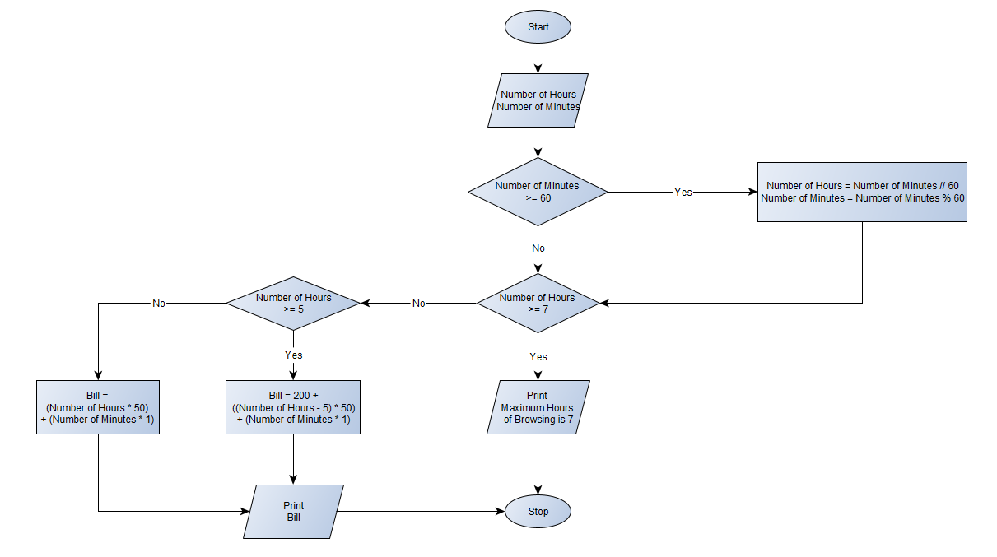

Python Program

print(**"The maximum number of hours of Browsing is 7"**)  
Number_of_Hours = int(input(**"Enter the number of Hours of Browsing : "**))  
Number_of_Minutes = int(input(**"Enter the number of Minutes of Browsing : "**))  
if Number_of_Minutes >= 60:  
 Number_of_Hours = Number_of_Minutes // 60  
 Number_of_Minutes = Number_of_Minutes % 60  
if Number_of_Hours >= 7:  
 print(**"The maximum number of hours of Browsing is 7. You can't exceed this limit"**)  
else:  
 if Number_of_Hours >= 5:  
 Bill = 200 + ((Number_of_Hours - 5) * 50) + (Number_of_Minutes * 1)  
 else:  
 Bill = (Number_of_Hours * 50) + (Number_of_Minutes * 1)  
 print(**"Bill :"**, round(Bill, 2))